Experiment 38

THE AUTOMATIC TELLER MACHINE (ATM)

AIM: To study and understand the formal design, specification and modelling of the ATM system using Finite State Machine

FINITE STATE MACHINE (FSM) :

A Finite State Machine is an abstract model of a system (physical, biological, mechanical, electronic, or software. Key components of a FSM are
- A finite number of states which represent the internal “memory” of the system
by implicitly storing information about what has happened before
- Transitions which represent the “response” of the system to its environment. Transitions depend upon the current state of the machine as well as the current input and often result in a change of state.

CONCEPTUAL MODEL OF THE ATM SYSTEM :

An ATM system is a real-time front terminal of automatic teller services with the support of a central bank server and a centralized account database. The ATM provides money withdrawal and account balance management services. It encompasses an ATM processor, a system clock, a remote account database, and a set of peripheral devices such as the card reader, monitor, keypad, bills storage and bills disburser. The conceptual model of an ATM system is usually described by a Finite State Machine (FSM) which adopts a set of states and a set of transitions modelled by a transition diagram or a transition table to describe the basic behaviours of the ATM system,
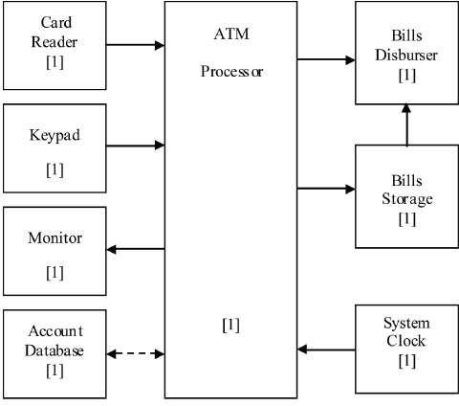

FORMAL DEFINITION OF THE FINITE STATE MACHINE :

Formal definition of the finite state machine can be written as ATM = (Q, 𝚺, δ, q0, F)
where
- Q → set of states {s0, s1, s2, s3, s4, s5, s6, s7}
S0 : System
S1 : Welcome
S2 : Check PIN
S3 : Input withdraw amount S4 : Verify balance
S5 : Verify bills availability S6 : Disburse bills
S7 : Eject card
- 𝚺 → set of events that the ATM may accept and process
𝚺 = { e0, e1, e2, e3, e4, e5, e6, e7, e8, e9, e10} e0 : Start
e1 : Insert card
e2 : Correct PIN
e3 : Incorrect PIN
e4 : Request ≤ max
e5 : Request > max
e6 : Cancel transaction e7 : Sufficient funds
e8 : Insufficient funds
e9 : Sufficient bills in ATM e10 : Insufficient bills in ATM
- q0 → start state
q0 = s1 (Welcome)
- F → set of accepting states
F = {s1}
- δ → transition function that determines the next state of the FSM on the basis of the current state and the incoming event. δ is defined as shown in the transition diagram and the transition table given below.
Transition Diagram :
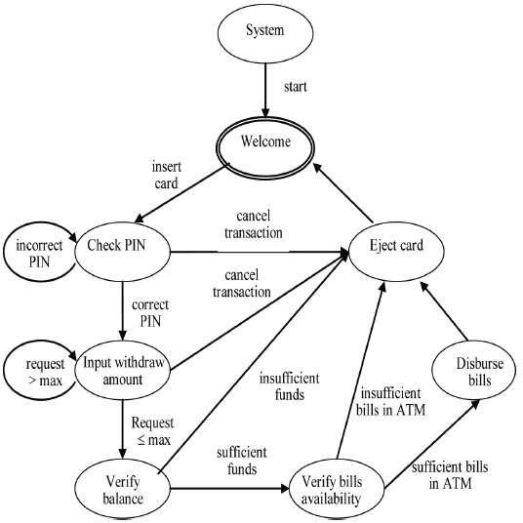

State Transition Table :

Present state | Input (Event) | Next State
s0 | e0 | s1
s1 | e1 | s2
s2 | e2 | s3
s2 | e3 | s2
s2 | e6 | s7
s3 | e4 | s4
s3 | e5 | s3
s3 | e6 | s7
s4 | e7 | s5
s4 | e8 | s7
s5 | e9 | s6
s5 | e10 | s7
s6 | - | s7
s7 | - | s1

RESULT:

The conceptual model of ATM system, its configuration, basic behaviours and logical relationships among components of the ATM system are studied

